[5 Mark]

**Use the table below to find:**

1. Lagrange second-order interpolation polynomial using the first three points.

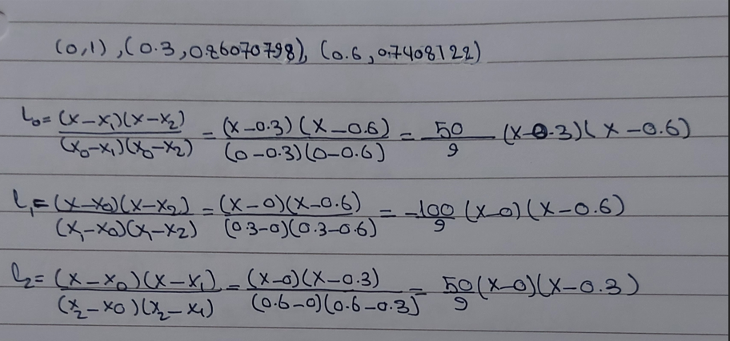

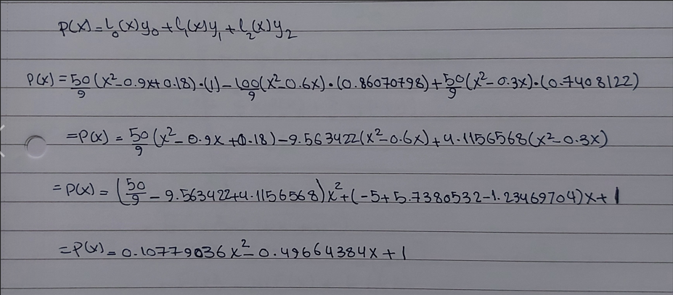

1. The first derivative using the forward difference method.

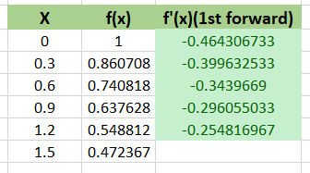

1. The first derivative using the central difference method.

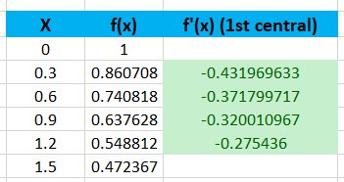

1. The second derivative using the central difference method.

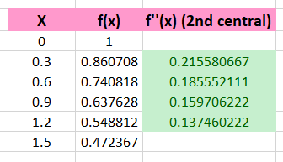

1. The integration using Trapezoidal rule.

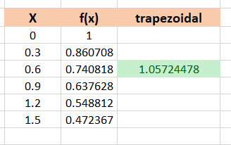

[Solve in Excel and upload your answers to BB]

